**CollabSync- Video Conferencing Platform**

**Overview**

CollabSync is a powerful and user-friendly platform designed to streamline virtual collaboration and communication. With a robust set of features including high-quality video and audio calls, screen sharing, chat, and file sharing capabilities, our app empowers teams and individuals to connect seamlessly from anywhere in the world. Our priority is ensuring a secure and reliable meeting environment, with encryption, access controls, and privacy features built-in. Whether you're hosting a small team meeting or a large-scale conference, CollabSync offers scalability and performance to meet your needs. Join us in redefining the way we connect and collaborate online.

### Features

**User Authentication**

• Users authenticate using credentials (username/password or OAuth) and receive a JWT token upon successful authentication.

• JWT tokens are used to authorize users for joining meetings and accessing resources.

**Meeting Management**

• Users can create new meetings and share the meeting code with other participants.

• Meeting details, such as participants, timestamps, and settings, are stored in the database. **Screen Sharing**

• Participants can share their screens with others in the meeting.

• Screen sharing uses the browser's built-in APIs to capture and transmit screen content.

**Video and Audio Options**

• Participants can enable/disable video and audio during the meeting.

• WebRTC handles real-time streaming of audio and video data between participants.

**Hand-Raising Feature**

• Participants can digitally raise their hands to indicate that they want to speak or ask a question. • The hand-raising status is displayed to other participants and meeting hosts.

**Real-Time Chat**

• Participants can do real-time chat via this platform during the meet.

**Technology Stack**

* **Frontend**:
  + React.js
  + Redux (for state management)
  + React Router (for routing)
* **Backend**:
  + Node.js
  + Express.js
  + MongoDB (with Mongoose ORM)
  + JSON Web Tokens (for authentication)
* **Others**:
  + Socket.io (for real-time communication)
  + WebRTC (for real-time chat)

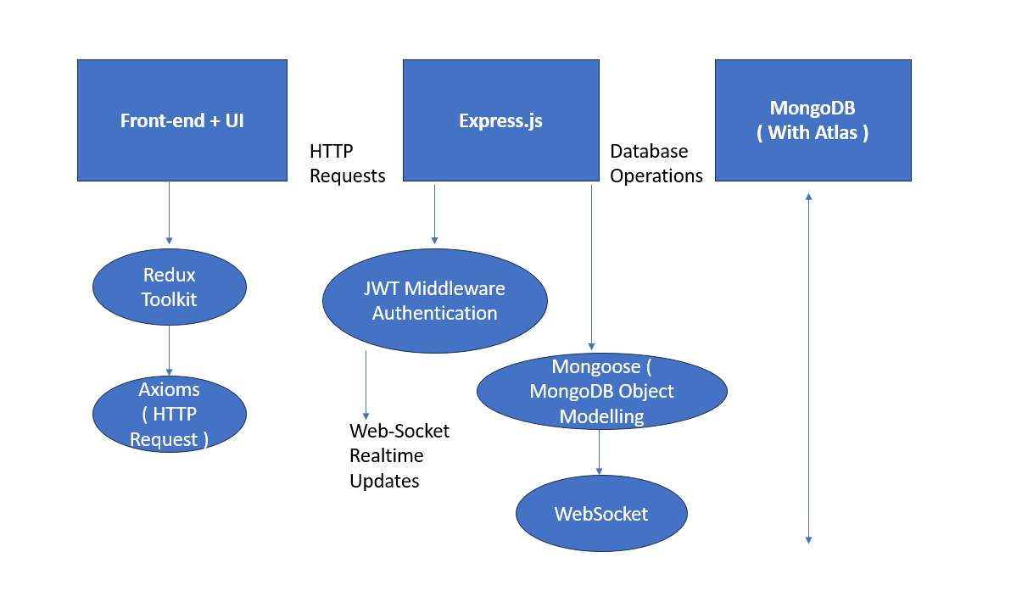

**Working of WebRTC**

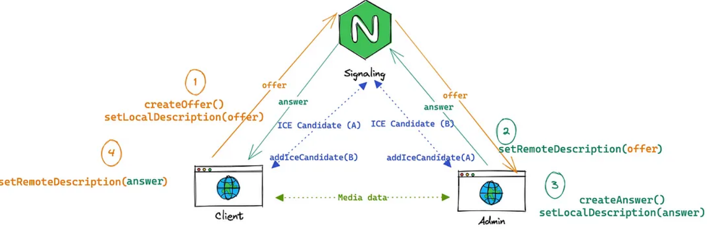

**Database Schema**

**Users**

* username
* email
* password

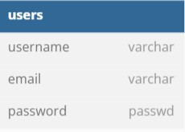

**Security Considerations**

* All communication between the client and server is encrypted using HTTPS.
* User authentication tokens (JWT) are securely generated and verified.
* Meeting URLs and codes are unique and randomly generated to prevent unauthorized access.

**Installation and Setup**

1. Clone the repository: **git clone** [**https://github.com/gargraghav82 /CollabSync.git**](https://github.com/gargraghav82%20/CollabSync.git)
2. Install dependencies for the client and server:
   * Client: **cd client && npm install**
   * Server: **cd server && npm install**
3. Configure environment variables:
   * Create a **.env** file in the server directory.
   * Define variables such as database connection URI, JWT secret, etc.
4. Run the development server:
   * Client: **cd client && npm start**
   * Server: **cd server && npm start**

**Conclusion**

CollabSync provides a seamless and secure environment for hosting and participating in online meetings. By leveraging WebRTC and Socket.IO, it enables real-time audio/video communication and collaboration while ensuring user privacy and security.